[*Published with MATLAB® R2022b*](https://www.mathworks.com/products/matlab)

**SIGNALS AND SYSTEMS**

**PROJECT-01**

**DR.B NIRANJAN KRUPA**

**Name: AKASH RAVI BHAT**

**SRN:PES1UG21EC025**

**Sem:3**

**Sec:A**

%1] Plot the Discrete time and continuous time signals using MATLABSolution  
% For continuous time  
t=[0:0.00001:1];  
y=(sin(6*(pi).*t)).^2;  
plot(t,y)%PLOTTING CONTINUOUS SIGNALS  
xlabel('time');  
ylabel('x[t]');  
title ('x v/s t');  
%For discrete time  
n=[0:1:20];  
x=(cos(2*(pi/20).*n));  
stem(n,x) %PLOTTING DISCRETE SIGNALS  
xlabel('time');  
ylabel('x[t]');  
title ('x v/s t');

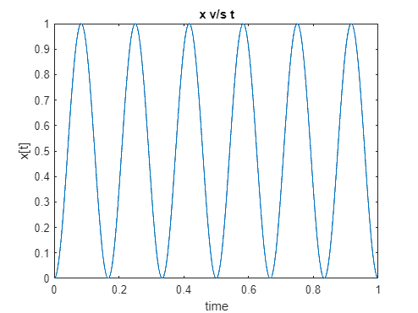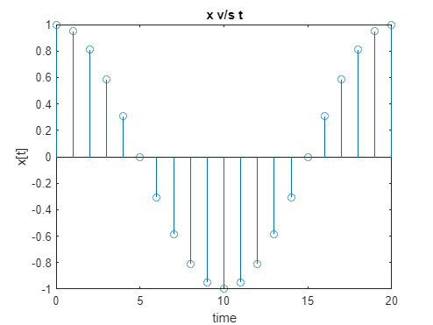

[*Published with MATLAB® R2022b*](https://www.mathworks.com/products/matlab)

%2] Calculation of Energy and power of signals  
%Solution:  
%MATLAB Code-  
%Find Energy and power of [continuous time]  
syms t;  
L=length(y);  
P = (norm(y)^2)/L  
E = P/t  
%Find Energy and power of [Discrete time signal]  
syms n;  
L=length(x);  
P = (norm(x)^2)/L  
E = P/n

P = 0.3750

E =

C:\Users\user\AppData\Local\Temp\ConnectorClipboard2882512834423438739\image16700680735762.png

P = 0.5238

E =

11/(21*n)

[*Published with MATLAB® R2022b*](https://www.mathworks.com/products/matlab)

%3]basic operation signals  
%in continuous time  
%solution  
t=[0:0.00001:1];  
y=sin(t);  
plot(t,y)  
title("original signal")  
%scaling  
z=sin(2*t);  
plot(t,z)  
xlabel('time');  
ylabel('x[t]');  
title ('scaled t');  
%shifting  
plot(t+2,z)  
xlabel('time');  
ylabel('x[t]');  
title ('shifted t');  
%discreate signal  
n=[0:1:20];  
y=(cos(2*(pi/20).*n));  
%scaling and shifting  
z1=(cos(2*(pi/20).*n*2))  
stem(n+2,z1)  
xlabel('n');  
ylabel('x[n]');  
title ('shifted and scaled n'); 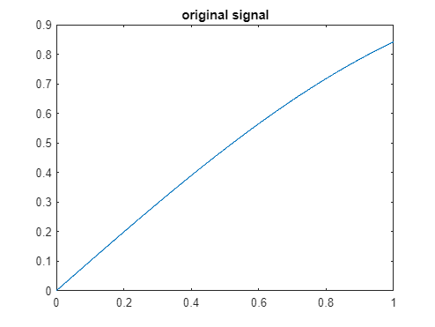

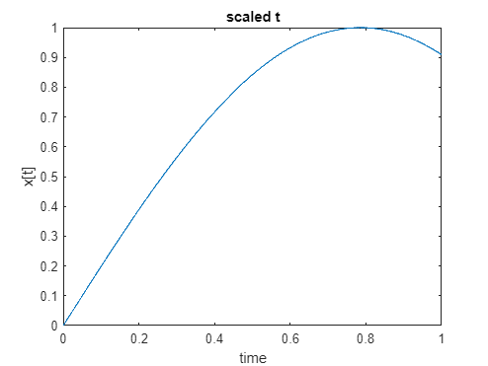

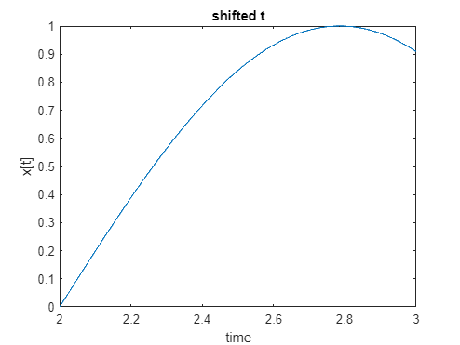

z1 = 1×21

1.0000 0.8090 0.3090 -0.3090 -0.8090 -1.0000 -0.8090 -0.3090 0.3090 0.8090 1.0000 0.8090 0.3090 -0.3090 -0.8090 -1.0000 -0.8090 -0.3090 0.3090 0.8090 1.0000

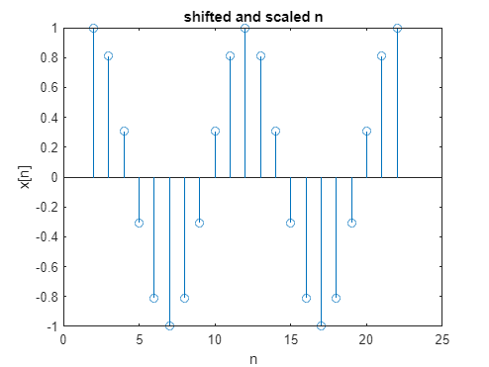

[*Published with MATLAB® R2022b*](https://www.mathworks.com/products/matlab)  
  
%4]Impulse response & step response of LTI systems  
%Ans:  
%a For the discrete time signal x[n] given by  
  
% find the impulse response and step response  
%MATLAB code-  
syms n;  
A = [1.5 -0.5;1 0];  
B = [0.5; 0];  
C = [0.3 0.8];  
D = 0;  
sys = ss(A,B,C,D,0.5);  
impulse(sys)  
step(sys)  
% for continuous time  
syms t;  
sys=tf(1,[1,2,1]);  
impulse(sys)  
step(sys)

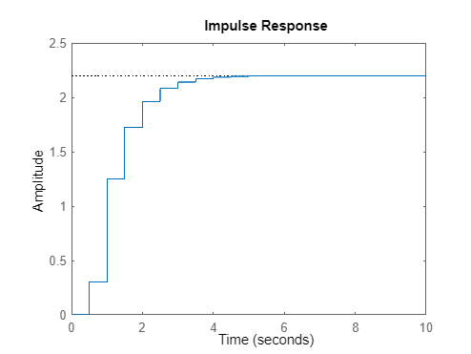

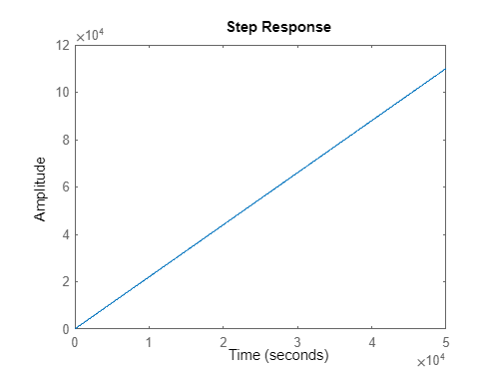

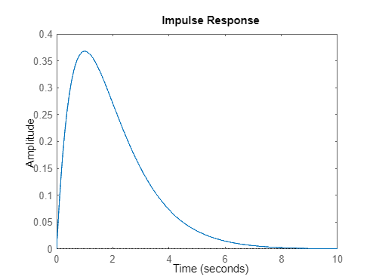

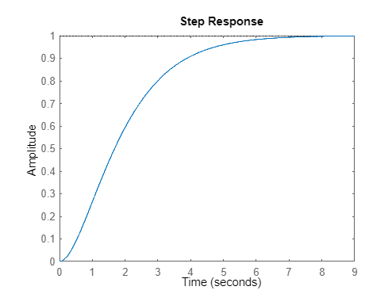

[*Published with MATLAB® R2022b*](https://www.mathworks.com/products/matlab)  
  
  
%5]Finding Discrete and continuous convolution  
%For x[n] = 2u[n] and h[n] = δ[n], find x[n]*h[n]  
%MATLAB Code-  
n= -25:25;  
x= 2*heaviside(n);  
h= dirac(n);  
y= conv(h,x);  
n1 = -25:length(y)-1-25;  
stem(n1,y ,'MarkerFaceColor',[0 1 1])  
%For x(t) = 5δ(t-1) + u(t+2) and u(t) = u(t-2), find x(t)*h(t)  
%MATLAB Code  
t= -50:50;  
x= 5*dirac(t-1) + heaviside(t-2);  
h=heaviside(t-2);  
y= conv(h,x);  
t1 = -50:length(y)-1-50;  
plot(t1,y ,'MarkerFaceColor',[0 1 1])

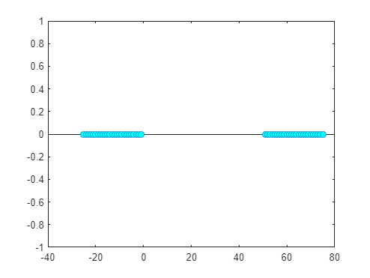

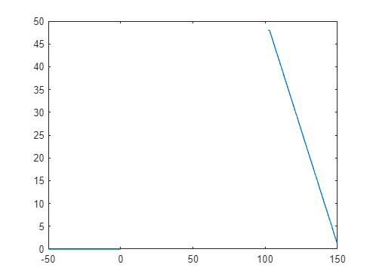

[*Published with MATLAB® R2022b*](https://www.mathworks.com/products/matlab)

%6]Solving Difference equations to find the zero input and zero state response  
%Determine the first 50 values of the step response of a system with a known impulse response h[n]=0.5n *u[n]  
%zero input response  
n = -2:10;  
x = zeros(length(n));  
b = [1]; a = [1 -0.5 1.5];  
c = [0 1];  
%initial conditions  
y = c;  
for i=3:13  
y(i) = y(i-2)*a(2) + y(i-1)*a(3) + x(i);  
end  
subplot(121);  
stem(n,y);  
title('Zero input response yzi(n)');  
%zero state response  
n=-2:10;  
b=[1];  
a=[1 -0.5 1.5];  
c=[0 1];  
x = [n>=0]; %u[n]  
c = [0 0]; %initial condition  
% c = [y(-2) y(-1)];  
y = [c];  
for i=3:13  
 y(i) = y(i-2)*a(2) + y(i-1)*a(3) + x(i);  
end  
  
subplot(122); stem(n,y);  
title('Zero state response yzs(n)')

z1 =  
  
 Columns 1 through 7  
  
 1.0000 0.8090 0.3090 -0.3090 -0.8090 -1.0000 -0.8090  
  
 Columns 8 through 14  
  
 -0.3090 0.3090 0.8090 1.0000 0.8090 0.3090 -0.3090  
  
 Columns 15 through 21  
  
 -0.8090 -1.0000 -0.8090 -0.3090 0.3090 0.8090 1.0000  
[*Published with MATLAB® R2022b*](https://www.mathworks.com/products/matlab)

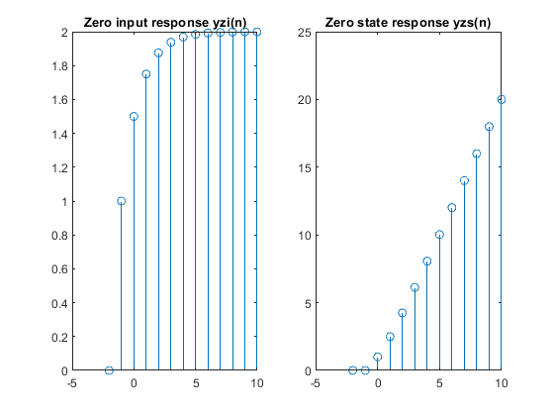

[*Published with MATLAB® R2022b*](https://www.mathworks.com/products/matlab)